- Need of Kafka:
  - Lets say you have a microservice architecture whre one service is calling other directly depending upon their needs.
  - For example, lets say one order service
order placed -> inventory update -> customer confirmation mail -> etc etc
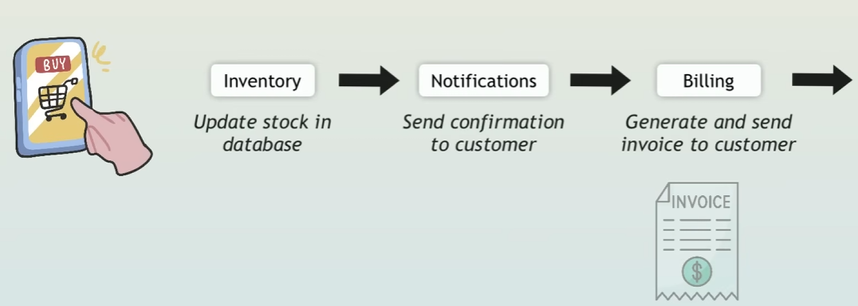
    - In this process, if the requests are too many and if one service gets stuck, then whole requests will be hampered.
    - Here every services are tightly coupled.
    - 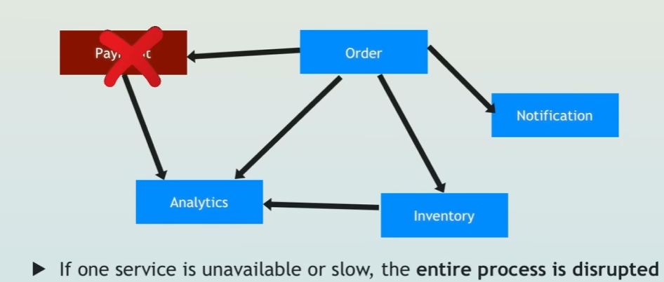
  - This is synchronous calls, what we want is asynchronous. Services should not interact with each other directly.
This is where message queue comes into picture.
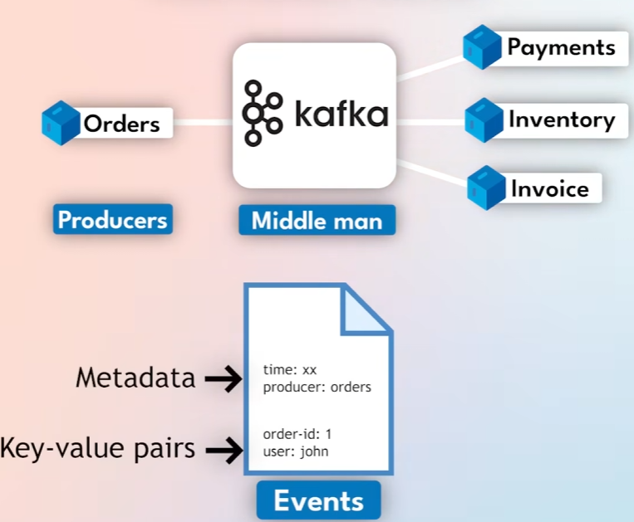
    - The services that create the events are called producers.

Where do the events get saved?
- In Kafka, the events are ordered logically, which are called topics.
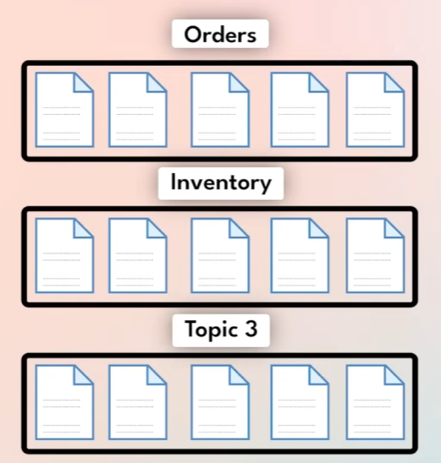
  - Here Orders topic, Inventory topic, Topic 3 .. are there.
  - NOTE: Topics are not physical storage, these are just there to separate the event types logically.
You can decide which topics has to be created based on your need.
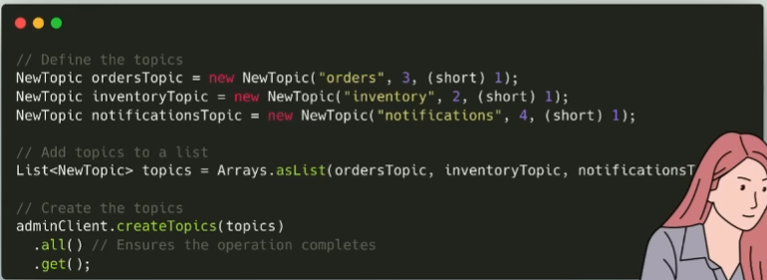
  - The Producer service will create event and handle it to Kafka. Because it trusts that Kafka will deliver the event to the right consumer(s).
- Consumers can subscribe to any topic.
  - When an event (consumer’s subscribed type) is generated by the producers, the consumer will get notified about that.
  - For example lets say one order has been created by customer
    - Orders service will create an event of Orders topic type.
    - Notification service will be notified on that and send notifications.
    - Inventory topic will also be notified and might create an Inventory topic event. And ..etc etc.
    - 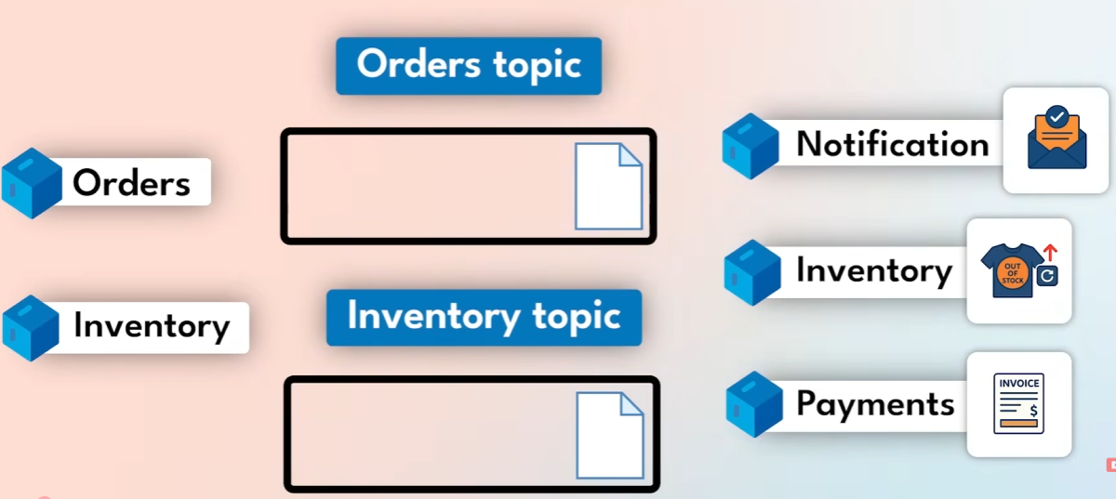
  - Chain of events can be triggered.
    - For example, one event is triggered and consumed by a service.
    - Now that service again created one event and so on.
- Now, as the events are logically separated with Topics, but it needs to be more specific.
  - For example lets say US Orders, India Orders, Africa Orders ..like this.
  - Now lets say, some consumers are there like US Order consumer, India Order consumers etc who will handled those partitions.
  - So, when you create multiple consumers for a particular partition, it is called Consumer Group.
    - In technical term, when you create multiple instances of a specific micro-service then it is called Consumer Group.
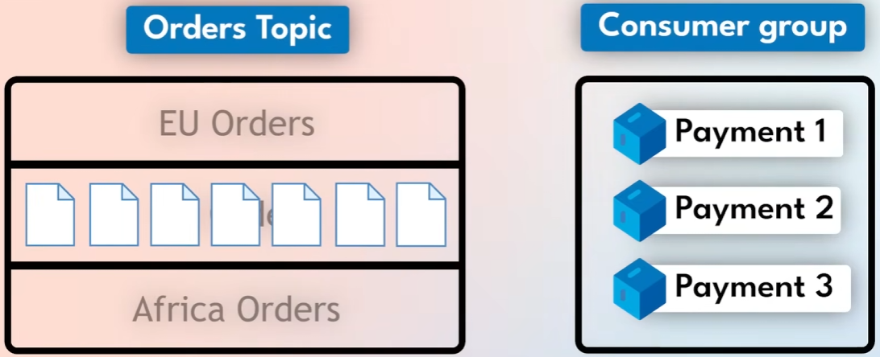
    - Kafka will distribute the load to the consumers of a consumer group automatically.
- At the end, the data is persisted (stored) in Kafka servers called Brokers as long as it is needed.
  - This is the difference between Kafka and other message queues.
  - In Kafka, the data are not disappeared after it is consumed by the consumers, it is persisted in the disk for future use or analytic purposes.

- F
- F

- In Simple Terms:
  - The events are logically divided into Topics. (Order, Inventory, …etc)
  - The Topics are further divided into Partitions. (Ind Order, EU Order …etc)
(I am dividing the topic by country)
  - Each partition can contain multiple messages like
order1, order2 …etc
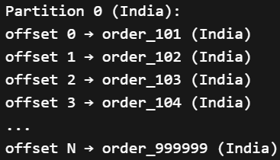
    - Each message inside the Partition will be having one unique offset.
    - Each time one order is placed in India, one message will be added to this India’s Order partition list.
  - Consumer Group is defined at Topic level (not Partition level).
    - The whole Consumer Group will subscribe to a Topic.
    - Its Kafka’s duty to assign the partition (of Consumer group’s subscribed Topic) to the consumer present inside that Consumer Group.
    - One partition can be assigned to only one Consumer.
      - Lets say you have 3 partitions in a topic, and 5 consumers inside the consumer group, then 2 consumers will always be idle.
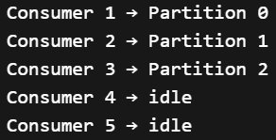
      - Max parallelism = number of partitions
    - Fewer groups + more partitions → better parallelism and performance
  - Kafka Broker is the actual system that stores & servers Kafka data.
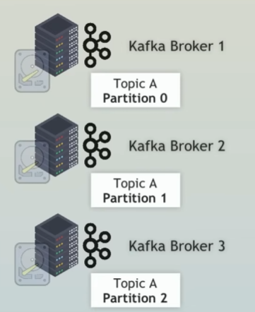
    - It handles produce requests (write data), consumer requests (read data).
    - One broker can contain multiple Partitions (from same or different topics)
  - Broker = physical storage + processing unit for partitions
Topic = logical stream of data, split into partitions for scalability
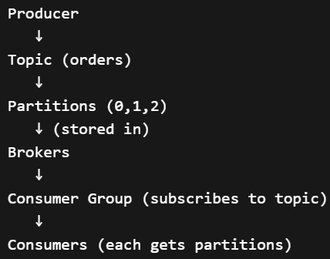
- F
- F
- F
- F
- F
- F
- F
- F
- F
- F
- F
- F

